**1. Software Engineering and why do we need it? (HR Question)**

Software is a program or **set of programs** containing instructions which **provide** **desired functionality**. And Engineering is the **processes of designing and building** something that serves a particular purpose and find a cost-effective solution to problems.

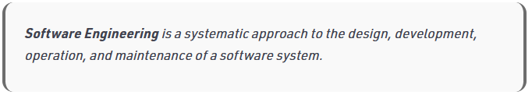

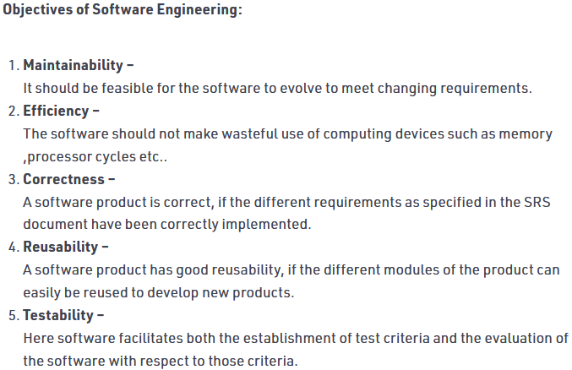 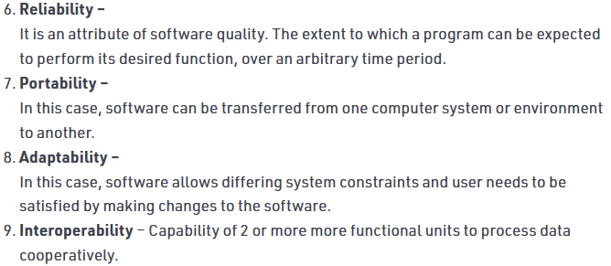

**2. Explain the classification of Software.**

**On the basis of application:**

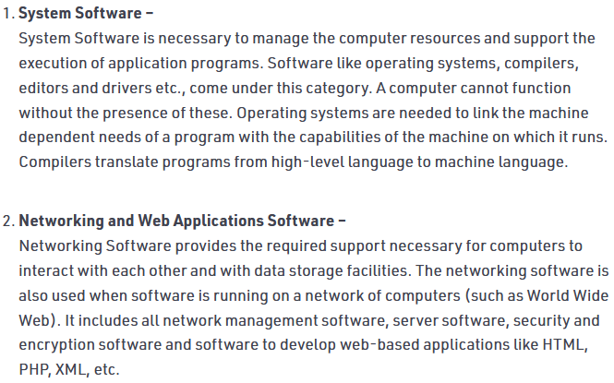 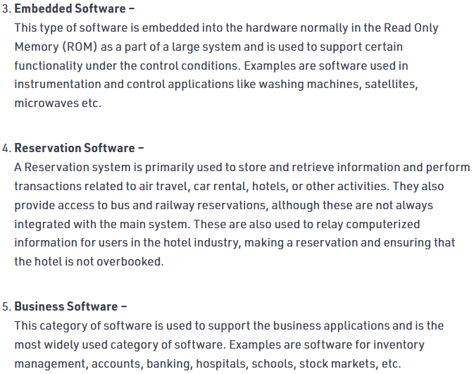 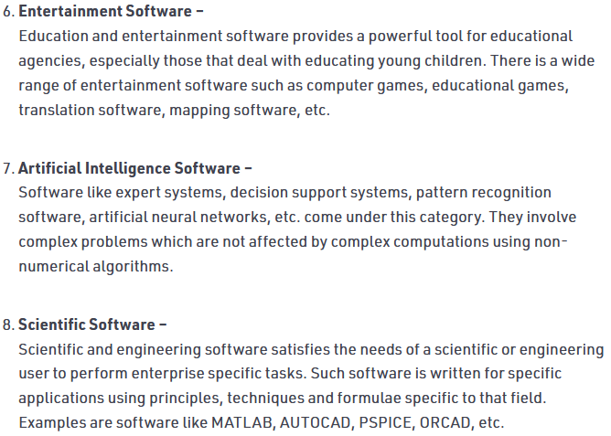 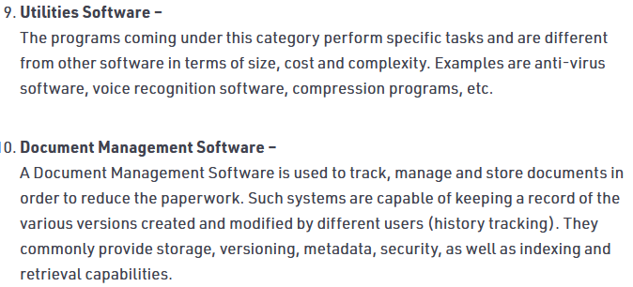

### On the basis of copyright:

### 

### 

**3. Software Development Life Cycle (SDLC).**